
STARS
School Transition & Adjustment Research Study

Stage 3: Finishing Year 7

QUESTIONNAIRE FOR YOUNG PEOPLE

A study about moving to secondary school

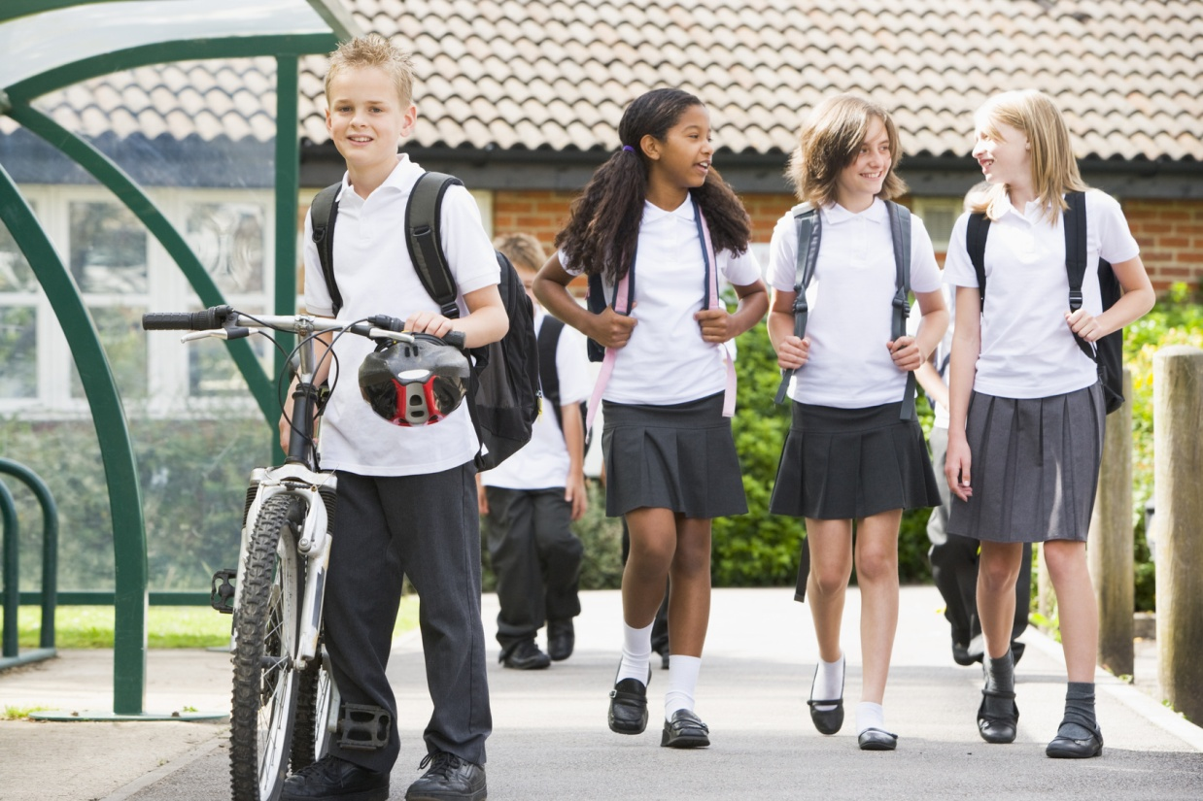

Your School
Here is an example of a rating scale:
1 2 3 4 5 6 7 8 9 10
Not at all worried
I get extremely worried about it

We would like to ask you some questions about any concerns or worries you may have about your new secondary school. Please rate each of the following using the scale above.
For example, if you were really worried you would put a 10 in the box beside it.
Example | 5
Making new friends |  | Older children |  | Lots of different teachers |  | Following a timetable
Being bullied |  | Getting to school |  | Homework |  | Dinner times
PE |  | Changing classes |  | Being able to do the work |  | Toilets
Remembering equipment for school |  | What to do if you are feeling ill |  | Lots of people |  | Break time
Size of school |  | Discipline and detentions |  | Losing old friends |  | Getting lost
If you have any other concerns you can write in the boxes below and then rate your concerns with the same scale as above.
................................................................................ |  |  |  | ................................................................................

 | Strongly Disagree | Disagree | Not sure | Agree | Strongly Agree
- I feel close to people at school | 1 | 2 | 3 | 4 | 5
- Teachers care about me | 1 | 2 | 3 | 4 | 5
- I feel part of my school | 1 | 2 | 3 | 4 | 5
- I feel happy at school | 1 | 2 | 3 | 4 | 5
- I feel teachers treat students fairly | 1 | 2 | 3 | 4 | 5
- I feel safe in my school | 1 | 2 | 3 | 4 | 5

If the statement is definitely true, tick ‘1’ for ‘YES!!’. If you think the statement is definitely not true, tick ‘4’ for ‘NO!!’. |  |  |  | NO!! | no |  | yes |  | YES!!
- I like my school |  |  |  | 1 | 2 |  | 3 |  | 4
- I wish I could go to a different school |  |  |  | 1 | 2 |  | 3 |  | 4
- I’m bored in my school |  |  |  | 1 | 2 |  | 3 |  | 4
- I would be very sad if I had to go to a different school |  |  |  | 1 | 2 |  | 3 |  | 4
- I hate being in this school |  |  |  | 1 | 2 |  | 3 |  | 4
- The teachers here really care about me |  |  |  | 1 | 2 |  | 3 |  | 4
- Teachers can’t be trusted; they say one thing at one time and something different the next time |  |  |  | 1 | 2 |  | 3 |  | 4
- The teachers here always keep their promises |  |  |  | 1 | 2 |  | 3 |  | 4
- The teachers here don’t care what I think |  |  |  | 1 | 2 |  | 3 |  | 4
- The teachers here always try to be fair |  |  |  | 1 | 2 |  | 3 |  | 4
- Teachers here punish children without even knowing what really happened |  |  |  | 1 | 2 |  | 3 |  | 4
- I feel safe and comfortable with the teachers in this school |  |  |  | 1 | 2 |  | 3 |  | 4
- Teachers in this school get cross whenever you make a mistake |  |  |  | 1 | 2 |  | 3 |  | 4
- When my teacher tells me not to do something I want to do, I know he or she must have a good reason |  |  |  | 1 | 2 |  | 3 |  | 4
- Our teacher will always listen to our ideas about how to make the class rules better |  |  |  | 1 | 2 |  | 3 |  | 4
Your School Work
 | Never | Seldom | Some-times |  |  | Often |  | Always
- How often do you try to learn something new even when you don't have to? | 1 | 2 | 3 |  |  | 4 |  | 5
- How often do you try to learn as much as you can about a new subject? | 1 | 2 | 3 |  |  | 4 |  | 5
- How often do you try to work hard to understand what you are studying? | 1 | 2 | 3 |  |  | 4 |  | 5
- How often do you try to find things to learn in class that are new and challenging? | 1 | 2 | 3 |  |  | 4 |  | 5
- How often do you try to show your teachers how clever you are? | 1 | 2 | 3 |  |  | 4 |  | 5
- How often do you try to learn things ONLY because you want to get a good mark? | 1 | 2 | 3 |  |  | 4 |  | 5
- How often do you try to make sure your teachers know you have been working hard? | 1 | 2 | 3 |  |  | 4 |  | 5
- How often do you try to get better marks than other children in your class? | 1 | 2 | 3 |  |  | 4 |  | 5
- How often do you try to show you've learned more than your classmates? | 1 | 2 | 3 |  |  | 4 |  | 5
- How often do you try to get more answers right than your classmates? | 1 | 2 | 3 |  |  | 4 |  | 5
- How much homework do you normally complete? | I don’t get homework | None | Not much |  |  | About half of it |  | All or most of it

Your Behaviour
How much does each of these sentences describe how you usually behave? | Not at all | Very little | Some-what | Quite a bit | Very much
- I am good at resisting temptation | 1 | 2 | 3 | 4 | 5
- I find it hard to break bad habits | 1 | 2 | 3 | 4 | 5
- I am lazy | 1 | 2 | 3 | 4 | 5
- I say inappropriate things | 1 | 2 | 3 | 4 | 5
- I do certain things that are bad for me, if they are fun | 1 | 2 | 3 | 4 | 5
- I refuse things that are bad for me | 1 | 2 | 3 | 4 | 5
- I wish I had more self-control | 1 | 2 | 3 | 4 | 5
- People would say that I have strong self-control | 1 | 2 | 3 | 4 | 5
- Enjoyment and fun sometimes keep me from getting work done | 1 | 2 | 3 | 4 | 5
- I have trouble concentrating | 1 | 2 | 3 | 4 | 5
- I can work well towards long-term goals | 1 | 2 | 3 | 4 | 5
- Sometimes I can’t stop myself from doing something, even if I know it is wrong | 1 | 2 | 3 | 4 | 5
- I often act without thinking through all my choices | 1 | 2 | 3 | 4 | 5

In the last 6 months… | Not True | Sort of True | Certainly True
- I try to be nice to other people, I care about their feelings | 0 | 1 | 2
- I am restless, I cannot stay still for long | 0 | 1 | 2
- I get a lot of headaches, stomach-aches or sickness | 0 | 1 | 2
- I usually share with others (food, games, pens, etc.) | 0 | 1 | 2
- I get very angry and often lose my temper | 0 | 1 | 2
- I am usually on my own. I generally play alone or keep to myself | 0 | 1 | 2
- I usually do as I am told | 0 | 1 | 2
- I worry a lot | 0 | 1 | 2
- I am helpful if someone is hurt, upset or feeling ill | 0 | 1 | 2
- I am constantly fidgeting or squirming | 0 | 1 | 2
- I have one good friend or more | 0 | 1 | 2
- I fight a lot. I can make other people do what I want | 0 | 1 | 2
- I am often unhappy, down-hearted or tearful | 0 | 1 | 2
- Other people my age generally like me | 0 | 1 | 2
- I am easily distracted, I find it difficult to concentrate | 0 | 1 | 2
- I am nervous in new situations. I easily lose confidence | 0 | 1 | 2
- I am kind to younger children | 0 | 1 | 2
- I am often accused of lying or cheating | 0 | 1 | 2
- Other children or young people pick on me or bully me | 0 | 1 | 2
- I often volunteer to help others (parents, teachers, children) | 0 | 1 | 2
- I think before I do things | 0 | 1 | 2
- I take things that are not mine from home, school or elsewhere | 0 | 1 | 2
- I get on better with adults than with people my own age | 0 | 1 | 2
- I have many fears, I am easily scared | 0 | 1 | 2
- I finish the work I am doing. My attention is good | 0 | 1 | 2

Your Friends
 | Not true at all | Hardly ever true | Some-times true | True most of the time | Always true
- It is easy for me to make new friends at school | 1 | 2 | 3 | 4 | 5
- I have nobody to talk to in class | 1 | 2 | 3 | 4 | 5
- I feel alone at school | 1 | 2 | 3 | 4 | 5
- I can find a friend in my class when I need one | 1 | 2 | 3 | 4 | 5
- I feel left out of things at school | 1 | 2 | 3 | 4 | 5
- I’m lonely at school | 1 | 2 | 3 | 4 | 5
- I am well liked by the children in my class | 1 | 2 | 3 | 4 | 5

